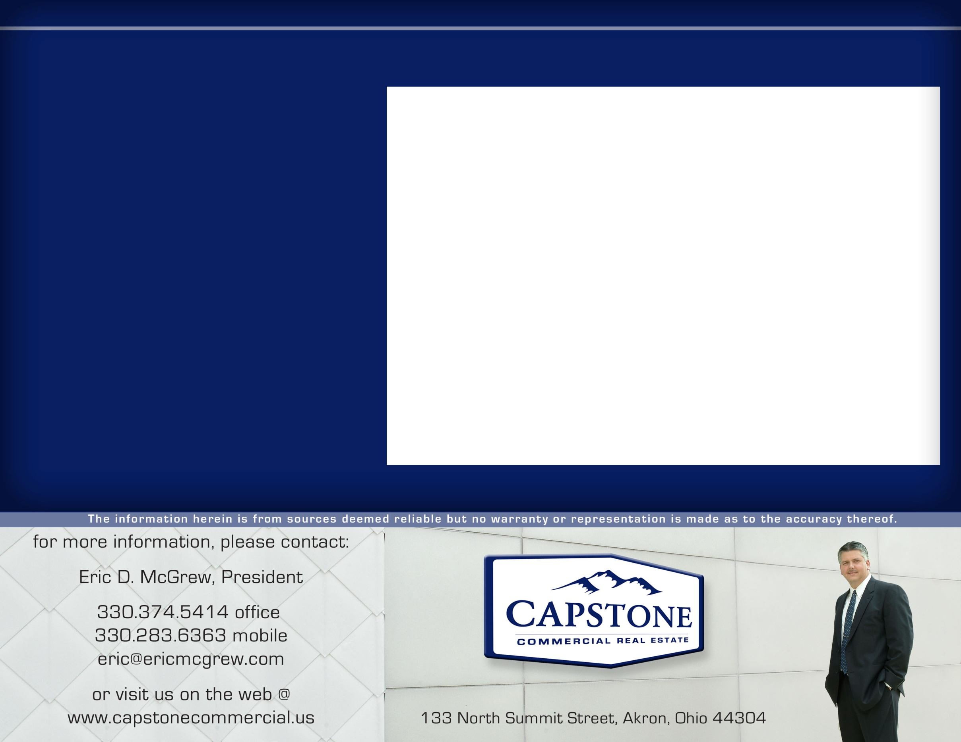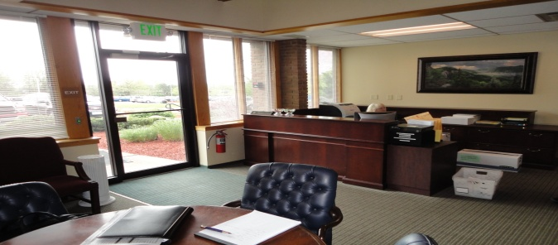InfoCision_Logo.png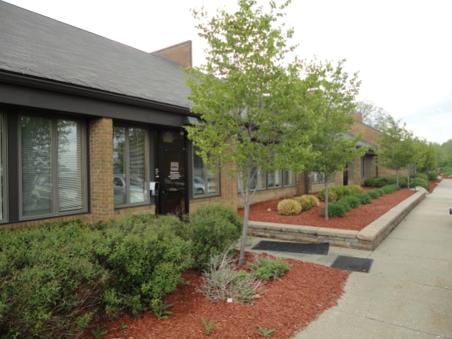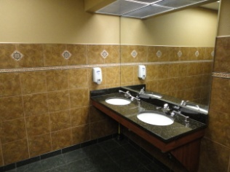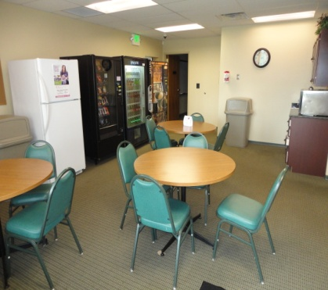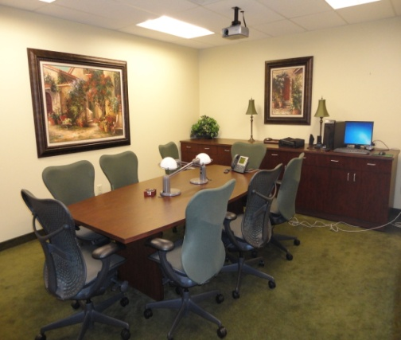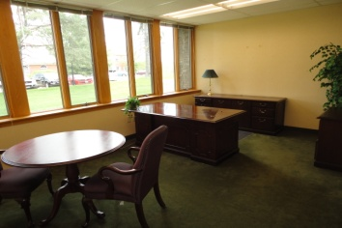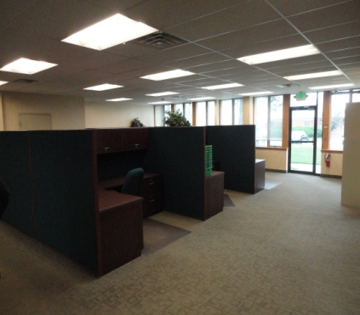

119 Ghent Road, Fairlawn, Ohio 44333

**PREMIER OFFICE SUITES IN BATH TOWNSHIP FOR LEASE!**

* This Class B office property totaling 17,448 SF is located near Springside Drive with easy access to Interstate 77 and State Route 18.
* Situated in a park-like setting with lots of windows, this building was designed so that it could easily be subdivided for up to 6 tenants.
* With an all masonry and glass exterior, each suite is 2,908 sf and includes a lobby, executive offices, conference room, employee lounge, restrooms, several open work areas, and an outdoor break area. Ample parking is available for up to 129 vehicles.
* Located on 2.72 acres and built in 1986, this property is in excellent condition and located adjacent to the popular Montrose shopping and fine dining mecca as well as Summit Mall in Fairlawn.
* Call today to arrange a private tour of 1, 2, or all 3 adjacent suites currently available!

**For Lease @ $14 psf**

**Call for Details**

**286 North Cleveland-Massillon Road, Akron, OH 44333**

*OFFICE BUILDING FOR LEASE*